LAPORAN PRAKTIKUM
PEMROGRAMAN WEB LANJUT
S1-SISTEM INFORMASI

“ LAPORAN PRAKTIKUM MODUL 2”



Disusun Oleh :
Nama | Kalvin Wibowo
NIM | 24.62.0220
Dosen Pengampu | Deni kurnianto Nugroho, S.Pd., M.Eng.
Nama Koordinator Asisten | Latif Ardiansyah
Kelas | 24BCIS01

S1 – SISTEM INFORMASI
FAKULTAS ILMU KOMPUTER
UNIVERSITAS AMIKOM YOGYAKARTA
2025

MODUL KE DUA

Variabel. Tipe Data dan Form Parameter

Tujuan
Setelah praktikum ini, praktikan diharapkan dapat : (isi dengan tujuan pembelajaran)
- Mampu menjelaskan pemahaman aturan variable dan konstanta, tipe data dan operator
- Memahami konsep penggunaan form parameter metode (POST dan GET)

Peralatan
- System operasi windows
- Visual studio vode
- Xampp
- Web browser mozilla firefox

Hasil dan Pembahasan
(isi dengan hasil dan pembahasan dari tugas anda, Pastikan screenshot jelas dan terbaca)
COPY PASTE CODING TEMAN NILAI default = 3
Anda boleh mengembangkan tampilannya, atau menambahkan identitas diri pada setiap file, namun inti dari script wajib tetap ada
- Screenshot Script, Output Latihan Praktikum dan penjelasan script
  - Screenshot Script, Output dan penjelasan script Latihan 1.4.1
Source code:
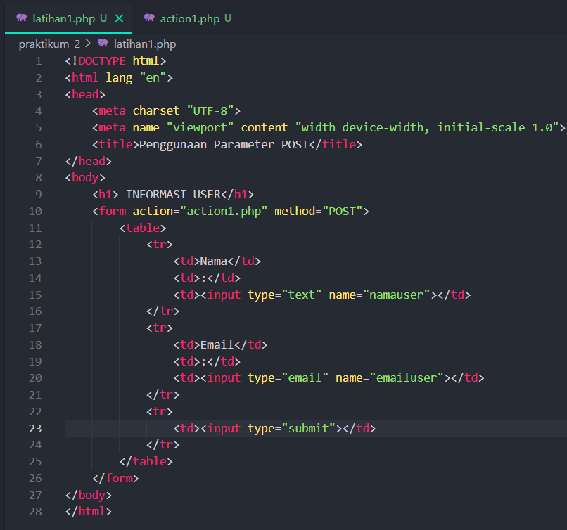
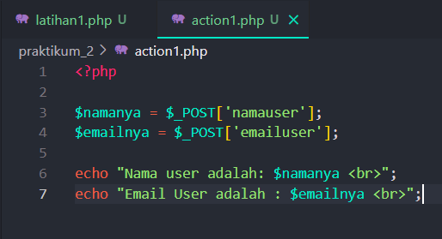
Output:
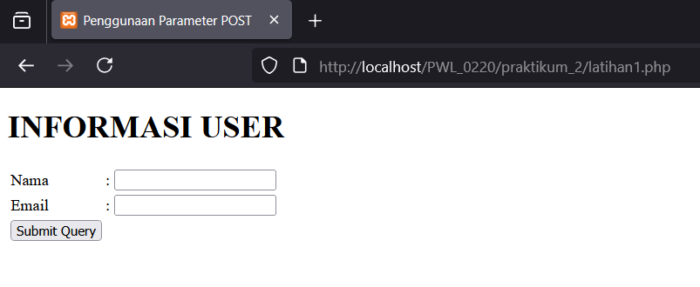
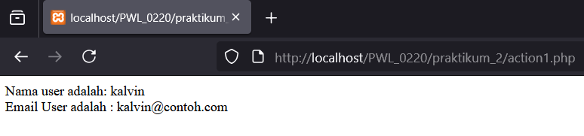
Explanation:
In this code, I make a post php program. With post method, sensitive information about user will never be leak by the program the difference from the GET method is GET method will show what happen in the program at the url bar

  - Screenshot Script, Output dan penjelasan script Latihan 1.4.2
Source code:
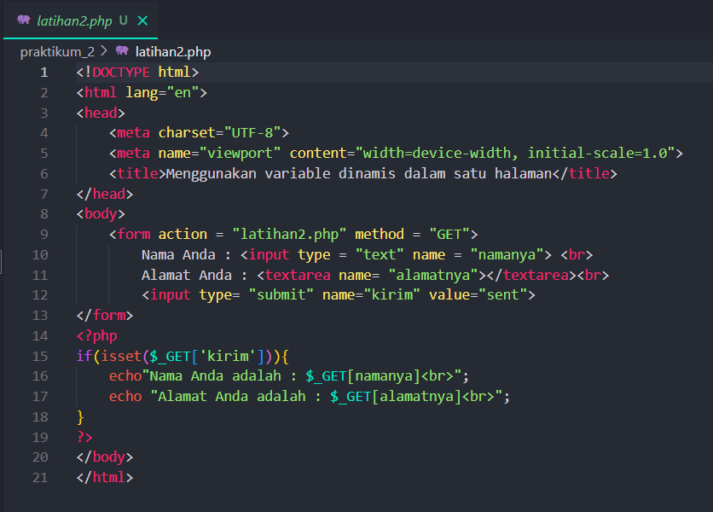
Output:
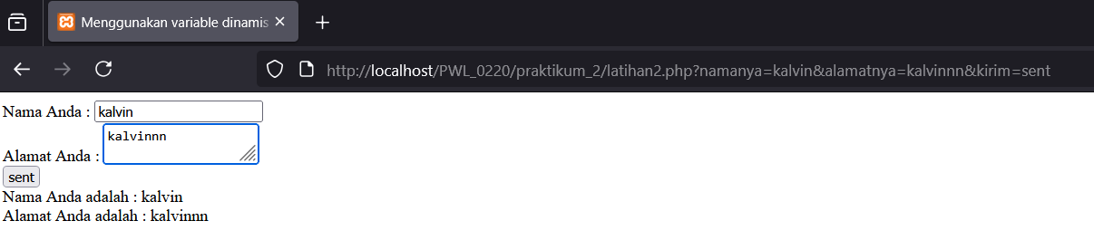
Explanation:
In this code, I use the GET method. As we can see, in the url bar, the system is automaticlly sending where the data is gonna send and keep. Meanwhile the POST method will just gonna show what is the name of the page in the url.
  - Screenshot Script, Output dan penjelasan script Latihan 1.4.3
Source code:
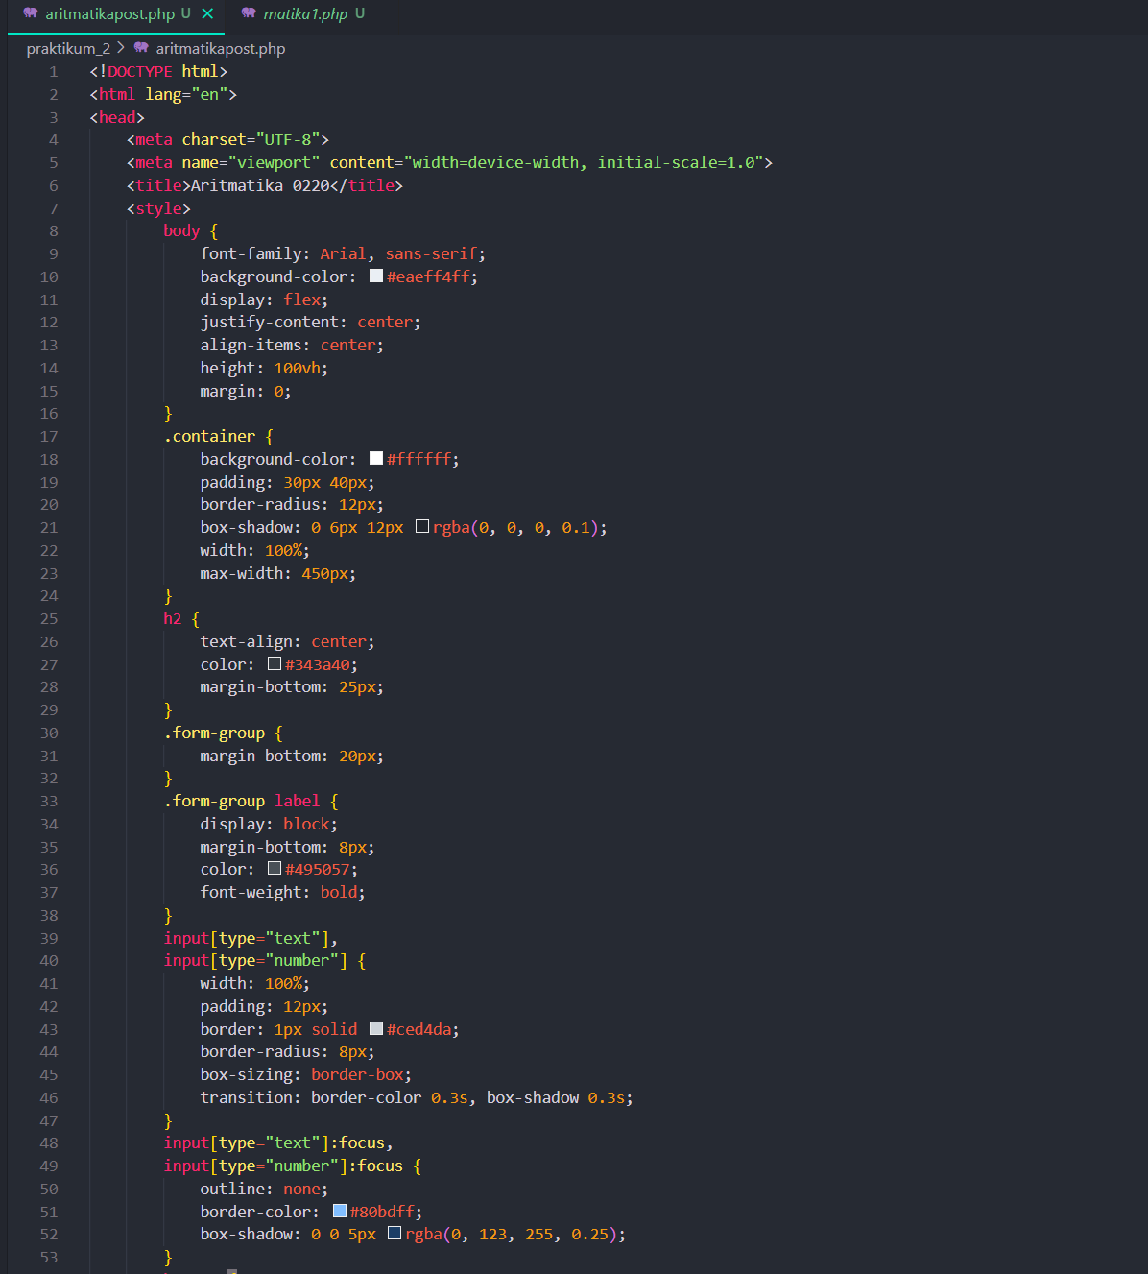
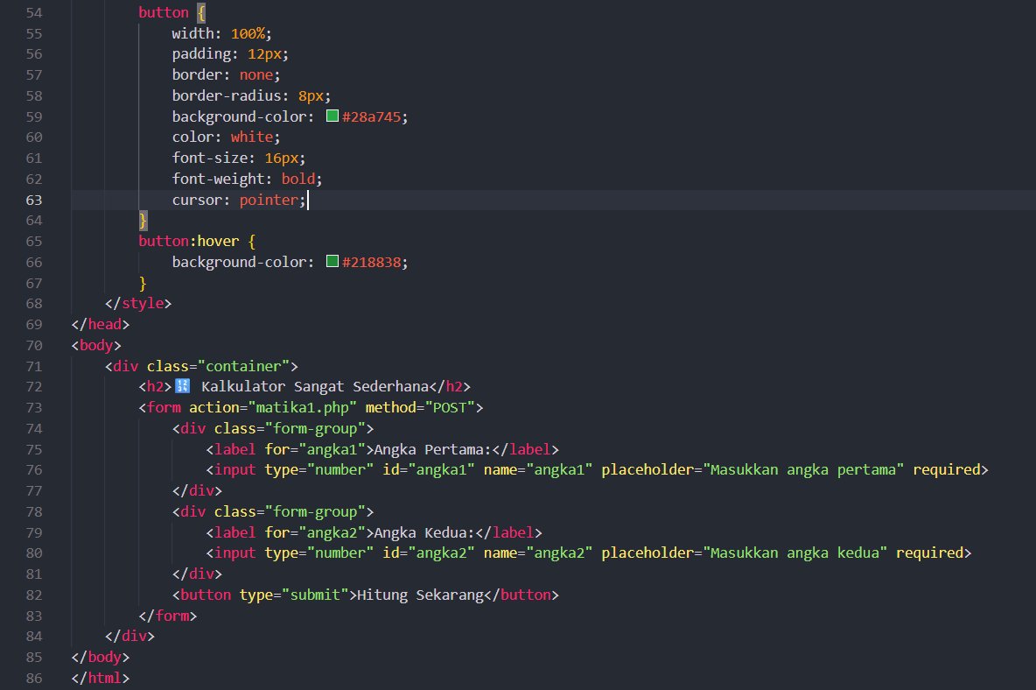
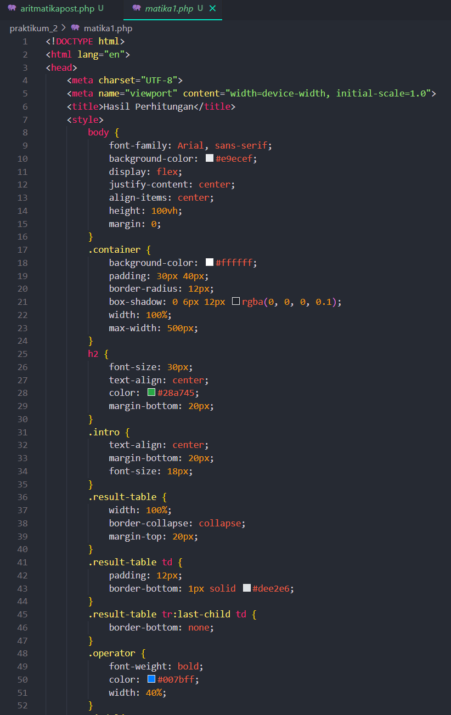
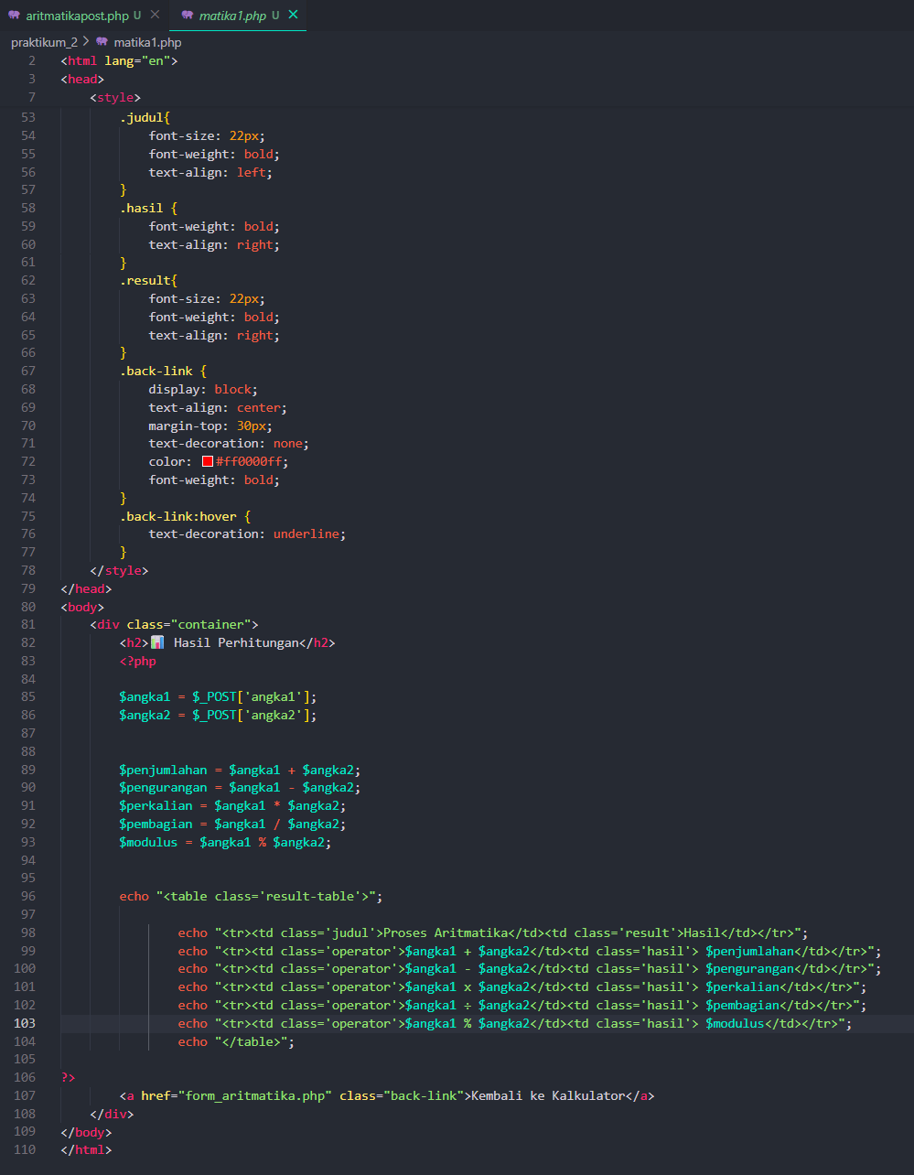
Output:
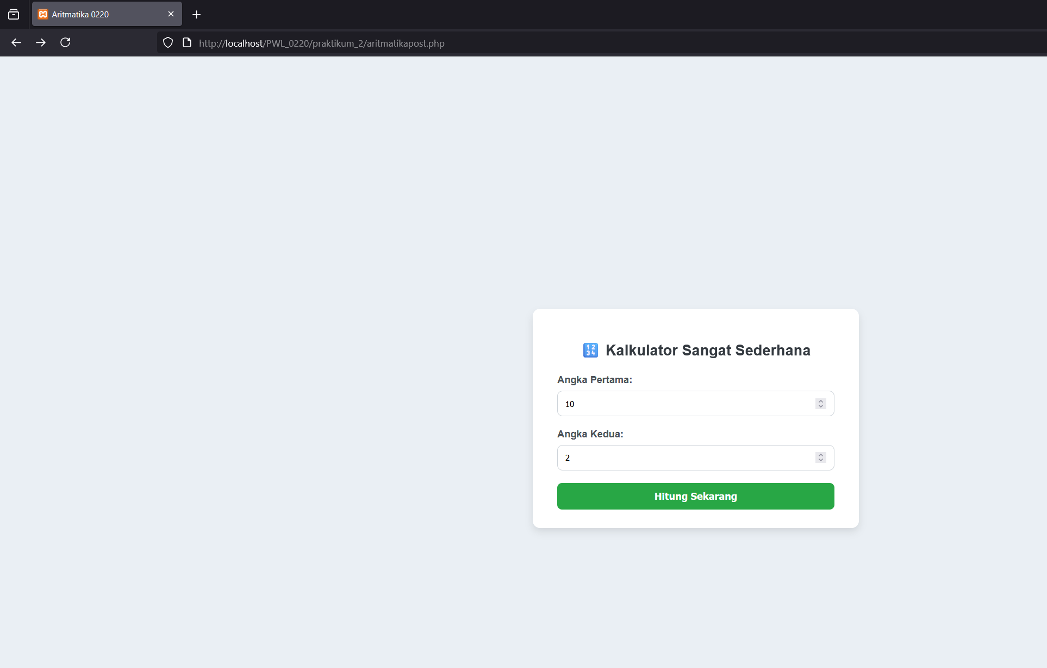
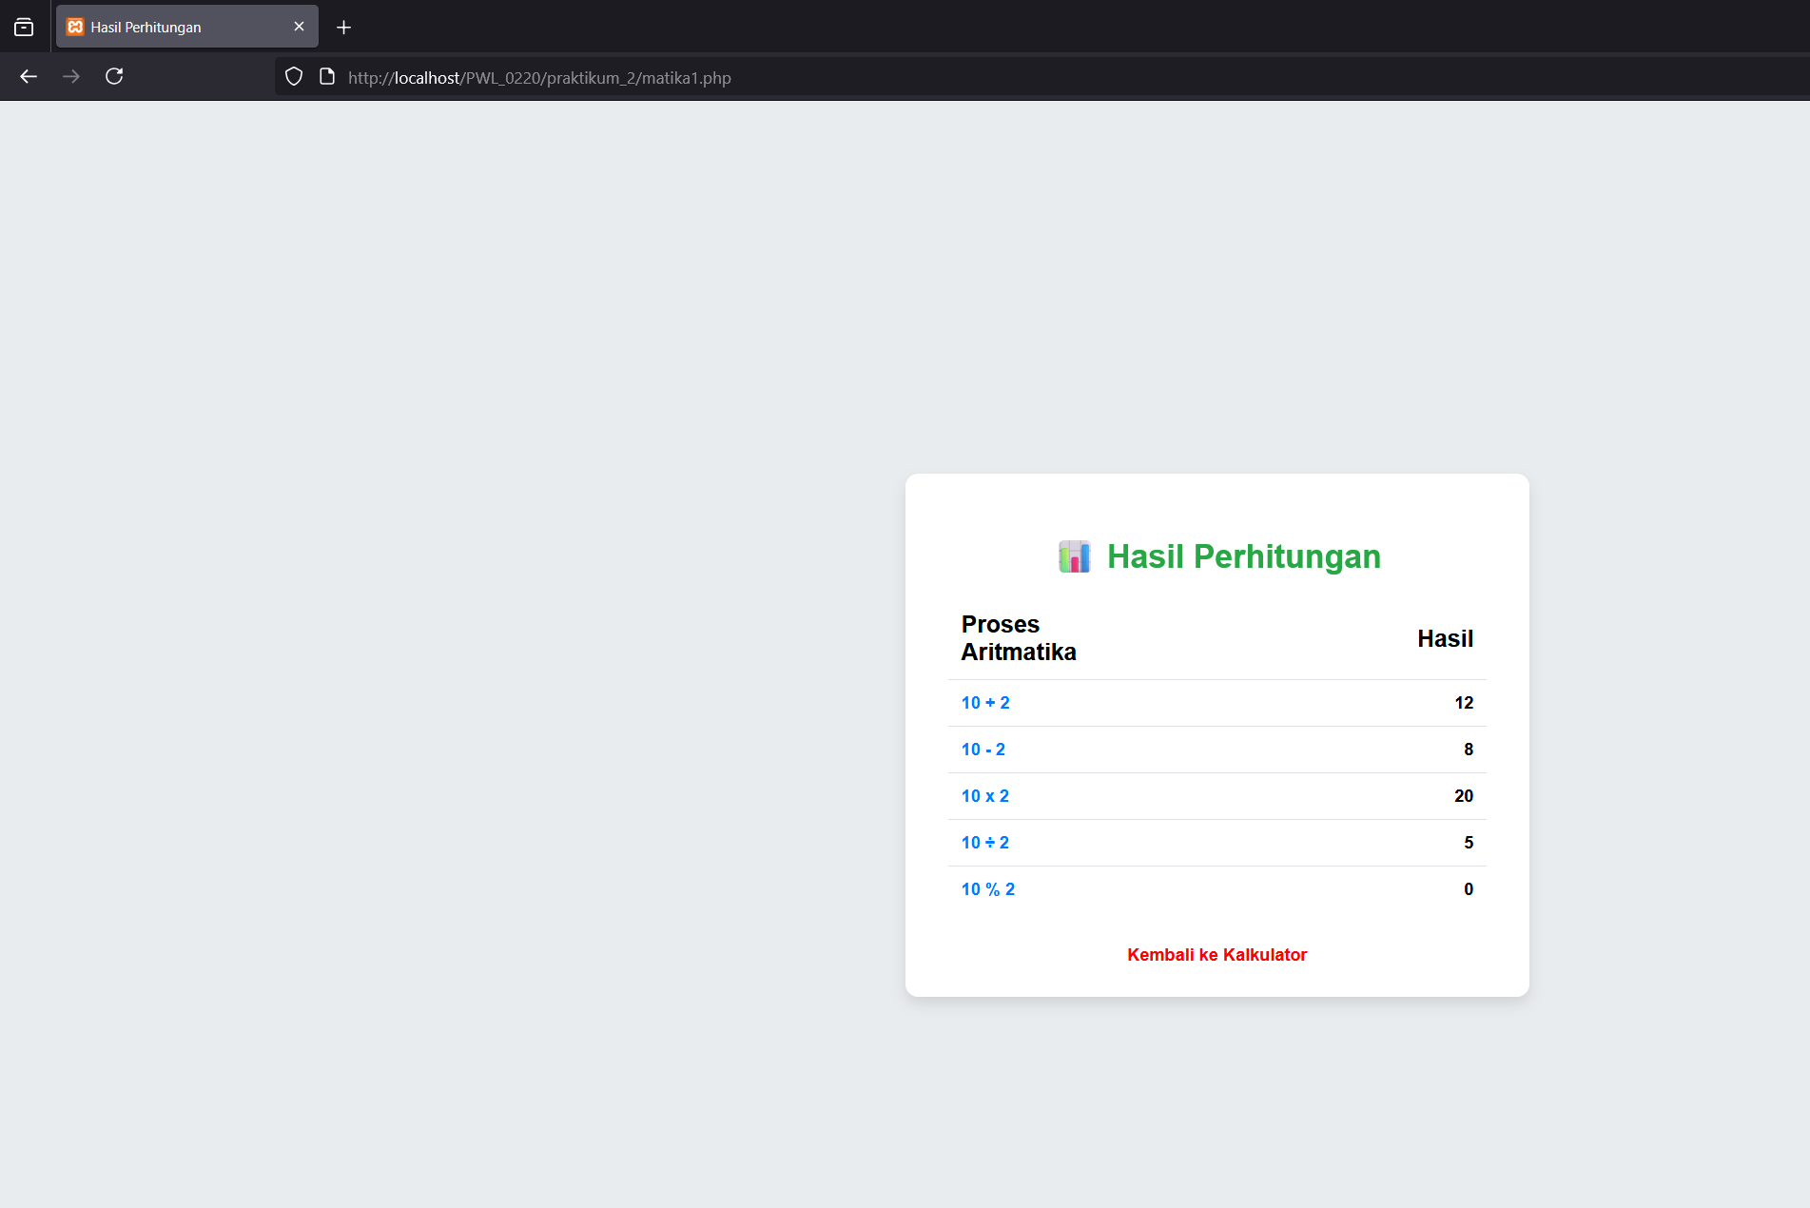
Explanation:
In this aritmathic code, I’m using post method. The css styling is internal inside the head section. For the body can floating, I’m using display: flex; justify-content: center; align-items: center; and height: 100vh;.
If we didn’t use display:flex, the floting box will by default put at the top left corner. If we didn’t use justify-content: center, the box not gonna be at the center of the screen, still at the center but at the left side. If we didn’t use align-items: center, the box will be extending up and down. If we didn’t use height:100 vh, the box will at the center but the box position will be at top center.

- Screenshot Script dan Output Tugas (Pastikan jelas dan terbaca)
Source code: 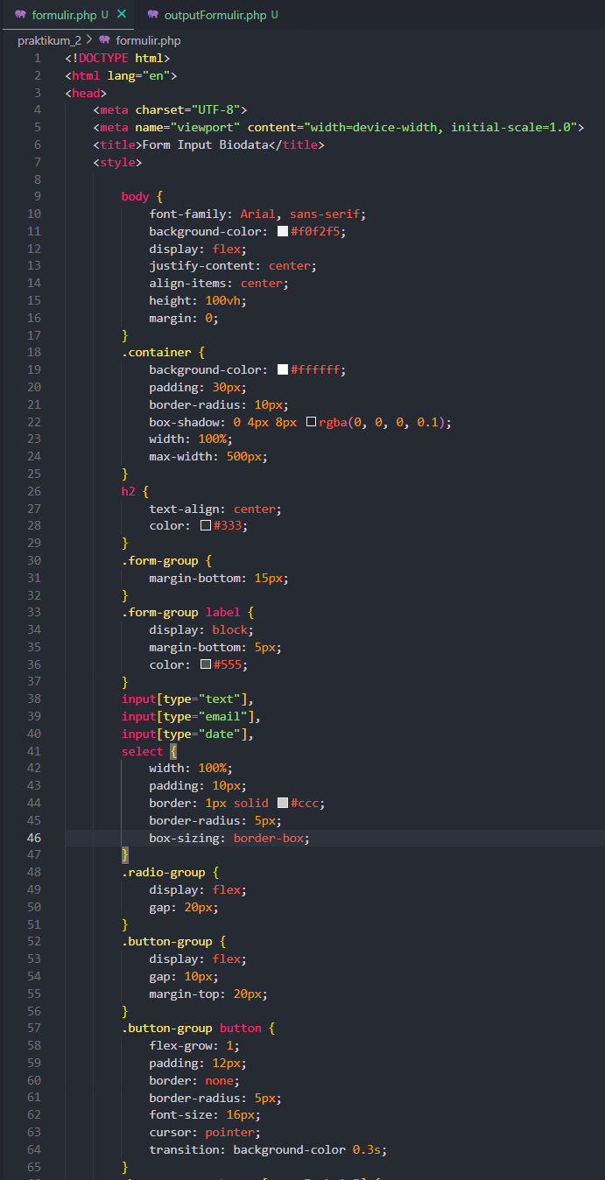
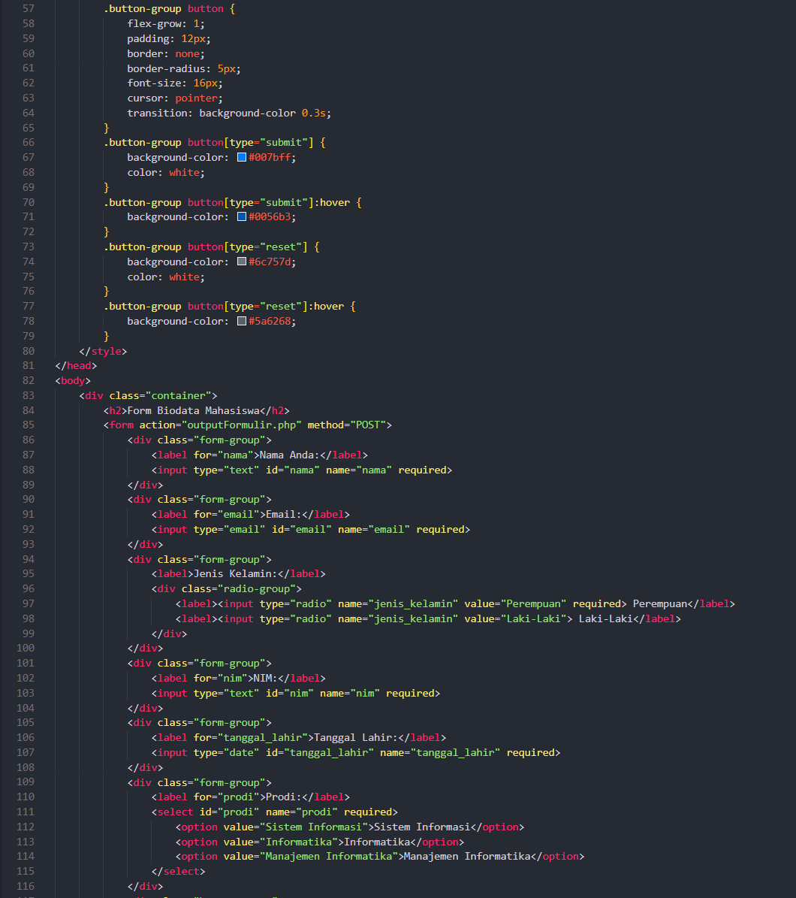
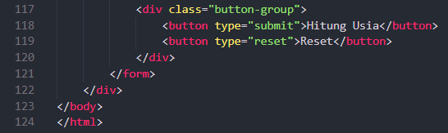
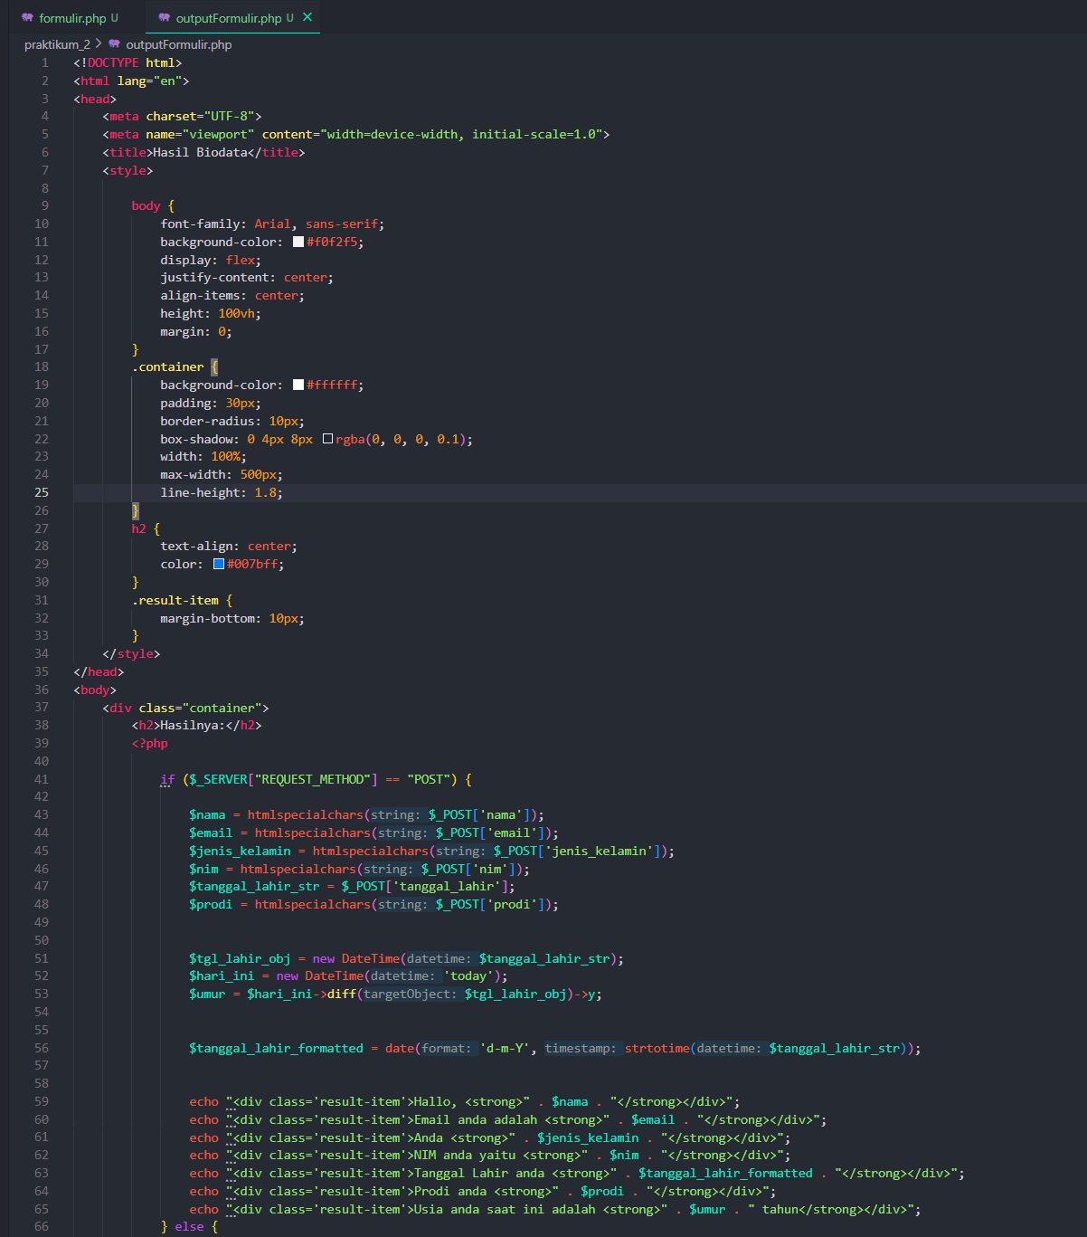
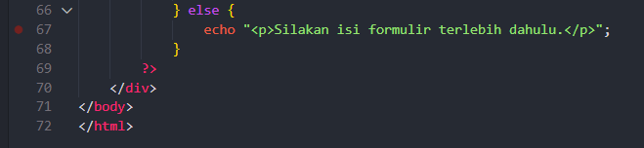

Output:
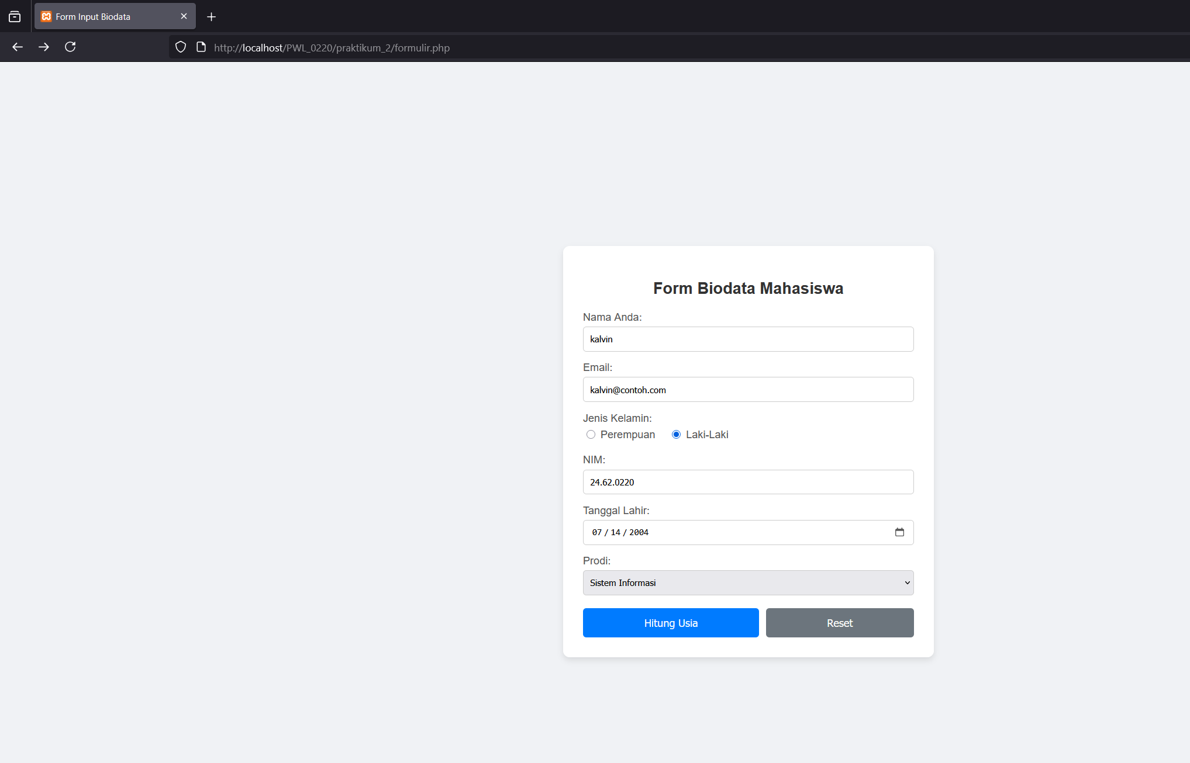
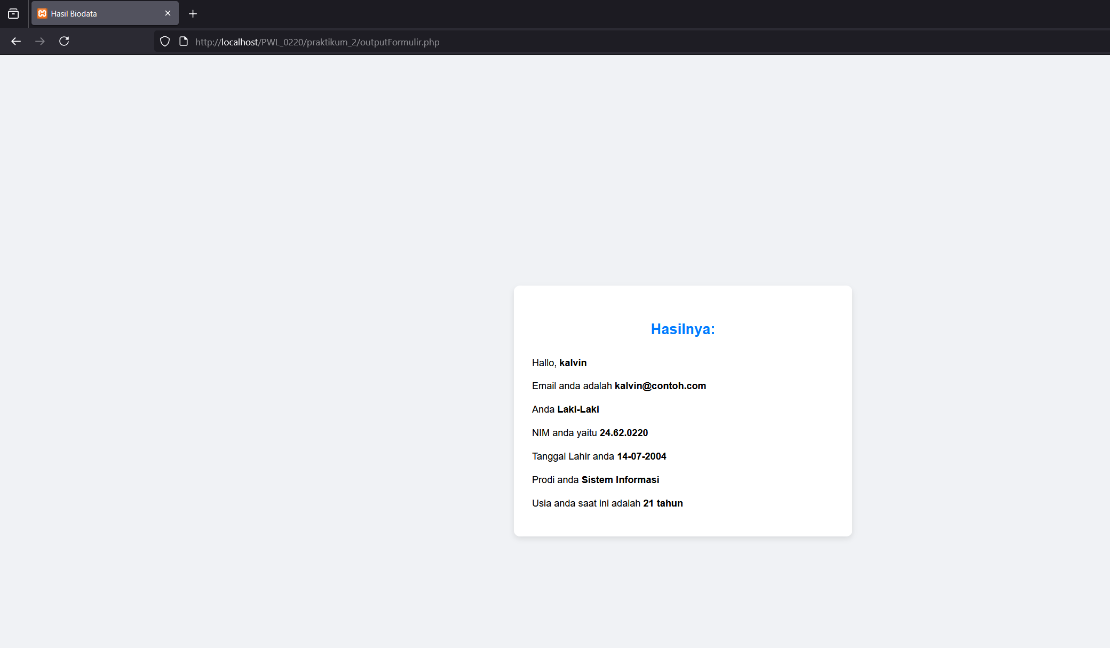

Explanation
In this code, I made two php files and linking one to another, in this case I link the outputFormulir.php to formulir.php. In the formulir.php, it will gonna be the input page. And in the outpuFormulir.php, the system will do the age counting in there. Using logic of reduced today date by input date.
$tgl_lahir_obj = new DateTime($tanggal_lahir_str);
$hari_ini = new DateTime('today');
$umur = $hari_ini->diff($tgl_lahir_obj)->y;
That 3 line of code is responsible for the age counting program. First we need to make a new variable as integer and using “new Date time” the system will convert the string date time to integer date time. After that we need to find today date time using ‘today’. After that, we need to reduced $hari_ini by $tgl_lahir_obj, the ->y is reffering to year in the date time position. And now $umur is containing the age of the user.

Eror /Kesulitan

Daftar Pustaka

https://www.guruprajab.com/belajar-php-mengenal-tanggal-dan-waktu-datetime-pada-php/
- https://www.w3docs.com/learn-php/new.html
- https://www.w3schools.com/php/default.asp

